七十八
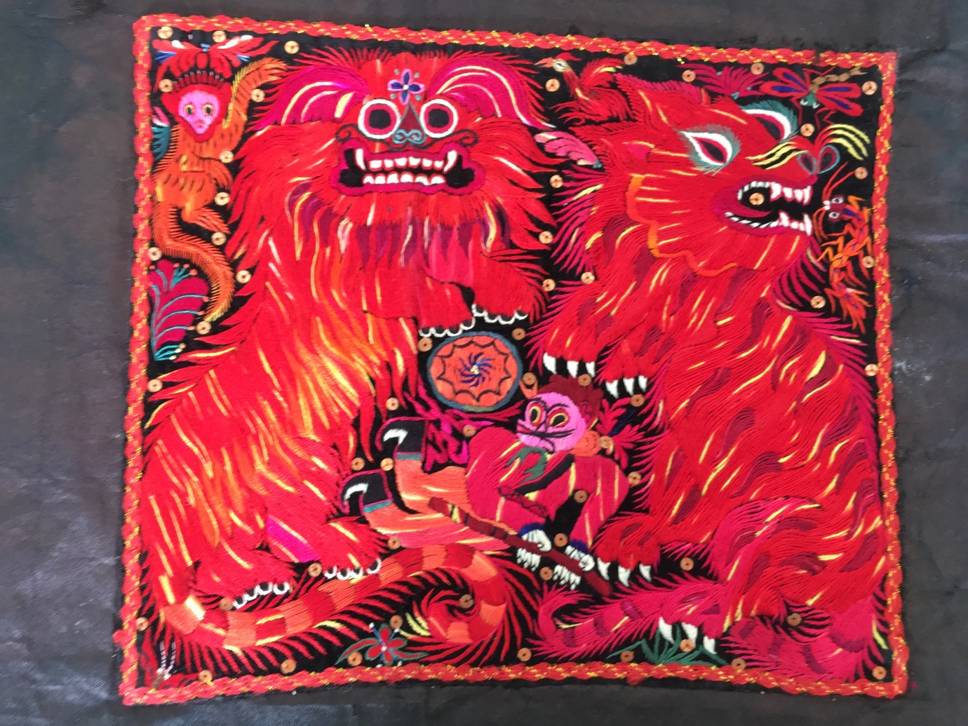
The province of Guizhou
was poor and remote
it’s said there were three things
they all lived without
no three feet of flatland
three days without rain
three pieces of silver
were in their domain

Chapter 78 – Poverty, Politics, and Pulchritude
In October 2015, China’s President Xi Jinping vowed to eradicate poverty among the remaining 70 million poor Chinese people by the year 2030. Actually, the poverty eradication initiative started in 1984 when Deng Xiaoping said in a meeting with foreign guests: “Socialism must eradicate poverty, and poverty is not socialism.” In 1978, there were 18 million people living in poverty in Guizhou. By 2018, that number had been reduced to 1.5 million. Xi relied on his own experience growing up in a small impoverished agricultural community in the north-western part of Shaanxi province in the 1950’s and 60’s. Xi reiterated his solemn pledge during the 18th National Congress of the CCP in 2020, that despite Covid-19, this goal shall be met. And in a surprising announcement in February 2021 President Xi announced that "the arduous task of eradicating extreme poverty had been fulfilled.” In real terms, that meant that no one in China would earn less than US$620 per year or about $1.69 per day.

Even though, the name Guizhou, can be translated as “rich land”, for most of its history, Guizhou has been one of the poorer provinces of China largely due to topography and isolation. Guizhou sits on an old eroding plateau called the Yunnan Guizhou Plateau (云贵高原 Yúnguì Gāoyuán.) It’s steep slopes, poor drainage, and red and yellow soil make it challenging for farming. Only about 3% of Guizhou’s land is suitable for anything other than terrace farming, and terrace farming requires large numbers of people working for little pay. Imagine not a hill, not a mountain, but a range of mountains sculpted by hand into steps of various sizes and shapes that all need to be maintained by an intricate system of irrigation controlled by massive numbers of men, women, and children using the most basic of farming tools.
Topography also made trade difficult since there were very few roads and no navigable rivers in Guizhou. Guizhou does have natural wealth, however, in terms of forests, plant and animal diversity. It is a treasure land to practitioners of Chinese medicine. New crops have been introduced that are more nutritious and have higher yields, both in terms of production and health benefits.
To address Guizhou’s poverty, there have been major initiatives throughout the province. A well-known idiom in China says: “If you want to become prosperous, you must first build roads” (要想富先修路 Yào xiǎng fù xiān xiū lù). Over 4,000 miles of new roads, highways, and modern suspension bridges have been built reaching some of the more isolated areas in the province.

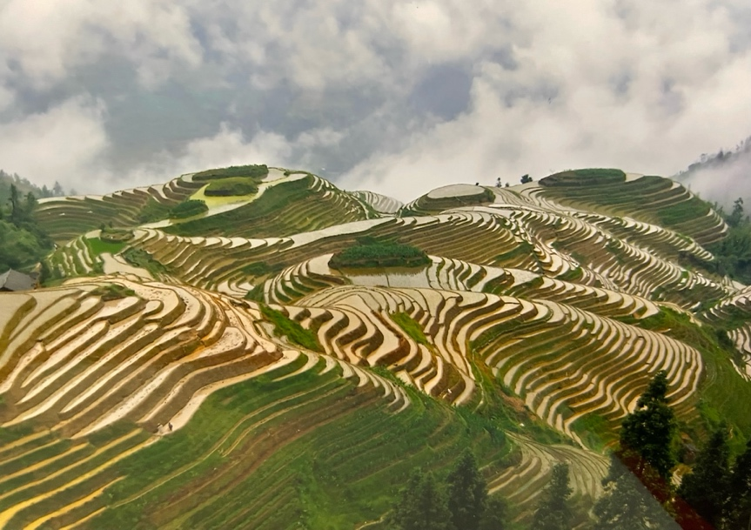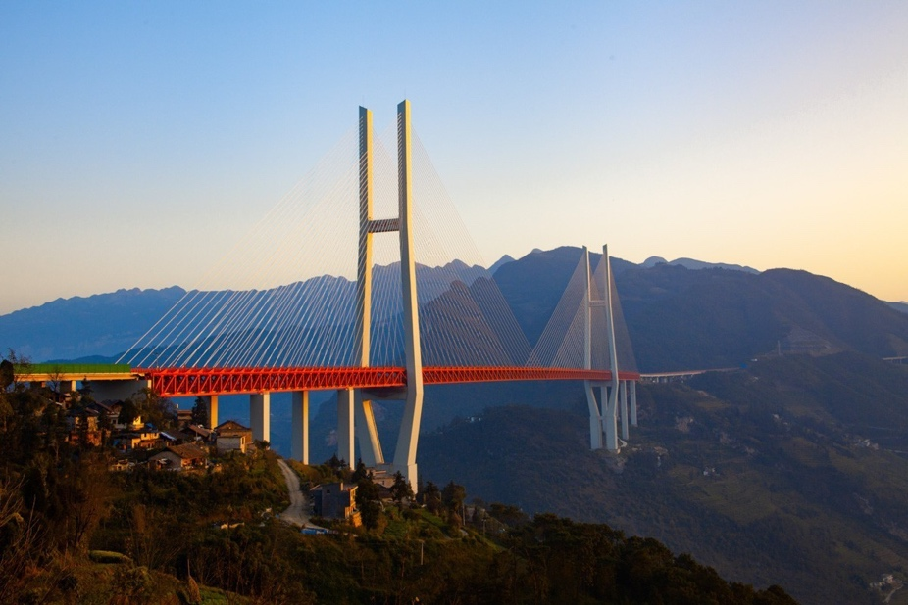

According to legend, the people from the Miao minority in Guizhou came from one of a dozen eggs laid by a butterfly mother whose origin was in a Maple tree. Among the remaining eleven eggs there was hatched a dragon, an ox, an elephant, a tiger, a thunder god, a centipede, a snake, a boy and a girl. Miao religion is animistic in nature. Shamans communicate with spirits. Animals, stones, trees, water, lightning, and thunder all play important parts in traditional Miao religion. The embroidery of the Miao people is striking. In a house outside of Kaili in western Guizhou, we discovered an artwork which was really a portion of a sleeve. The two lions depicted represent the autumn harvest celebration and the deep red color symbolizes fortune and prosperity. The cotton fabric was made by the Miao people and dyed red to become “cow blood fabric.” The fabric was coated with egg white to give it a kind of sheen or gloss and to make the fabric water resistant. Indigo is also prevalent in Guizhou. Blue indigo actually comes from green leaves. Indigo leaves are crushed and left in a vat of water to ferment. After a few months, quick lime is added and the result is indigo. Cotton fabric is soaked in the dye and then hung to dry. If the color is not dark enough, the fabric may be dipped again until it reaches the desired shade of blue. Indigo is still the primary dye used in making blue jeans. Sometimes hemp is used instead of cotton and similar techniques are used to preserve the hemp cloth. Hemp fibers, however, are much shorter than cotton and unsuitable for spinning.
Besides the beautiful embroidery, Miao people are also silver artisans. Miao women adorn themselves with an abundance of silver jewellery which typically includes necklaces, earrings, bracelets, rings, and even heavy silver tiaras and crowns. Sometimes these crowns are adorned with silver horns or flowers. Women wear silver “vests” decorated with all kinds of bling. Silver is also used by the Miao to test the purity of water and to fight disease and misfortune. Like many arts in China, however, silver artisans are a dying breed since this art is time consuming and takes patience and persistence. The results are both delicate and elegant.
In the far southeast of Guizhou lies the ancient Dong village called Zhàoxìng (肇兴镇.) If you were to meander through Zhaoxing, the largest and most accessible Dong village, you couldn’t help but feel that you’ve entered a time warp. The village rests in an idyllic setting surrounded by jade-colored hills with a river flowing through it. The houses are almost all constructed of wood with many built on stilts. There are five drum towers, one for each of five Confucian virtues: Rén 仁 (benevolence), Yì 义(righteousness), Lǐ 礼(ceremony), Zhì 智(wisdom), and Xìn信(integrity). Each bridge is unique in style and design.

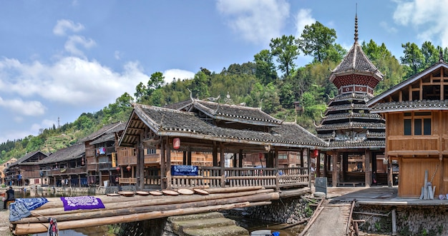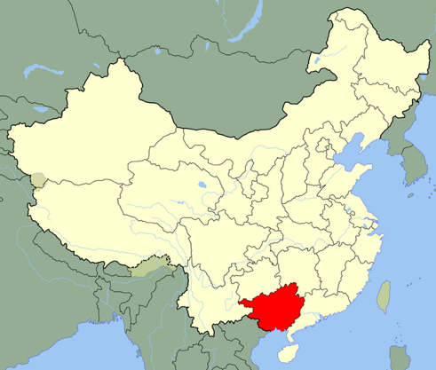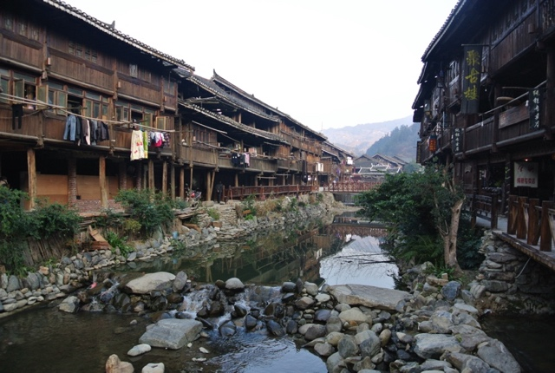

Each covered bridge is made of wood, wide enough for a bus to go over, but made for people, not vehicles. Held aloft by five rectangular pillars made of concrete and stone, these are open bridges which support multi-level towers (one on top of each pillar.) There are benches and railings along the entire distance of the bridges where old men are playing xiangqi (Chinese chess,) young couples are courting, and people of all ages are socializing and exercising. All along the bridges on the walls of the towers are carved and painted works of art. Calligraphy and auspicious flowers, dragons, gourds, cranes abound. And structurally, strong mortise and tenon joints alleviate the need for a single nail or screw. These are the Wind and Rain Bridges of the Dong minority.

